42.38: From the result of Problem (42.9), the moment inertia of the molecule is

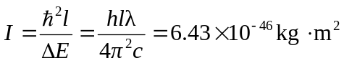
and from Eq. (42.6) the separation is

